**Vishal Jha**

**Python Assessment - 29/01/24**

Today we started with conditional statements like If, if else, if elif else.

**If - else statement :**

If condition :

Statement

Else :

Statement

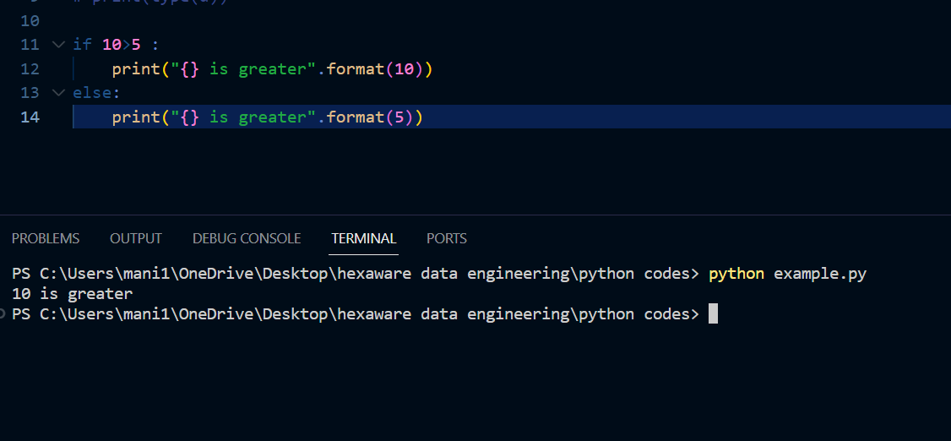

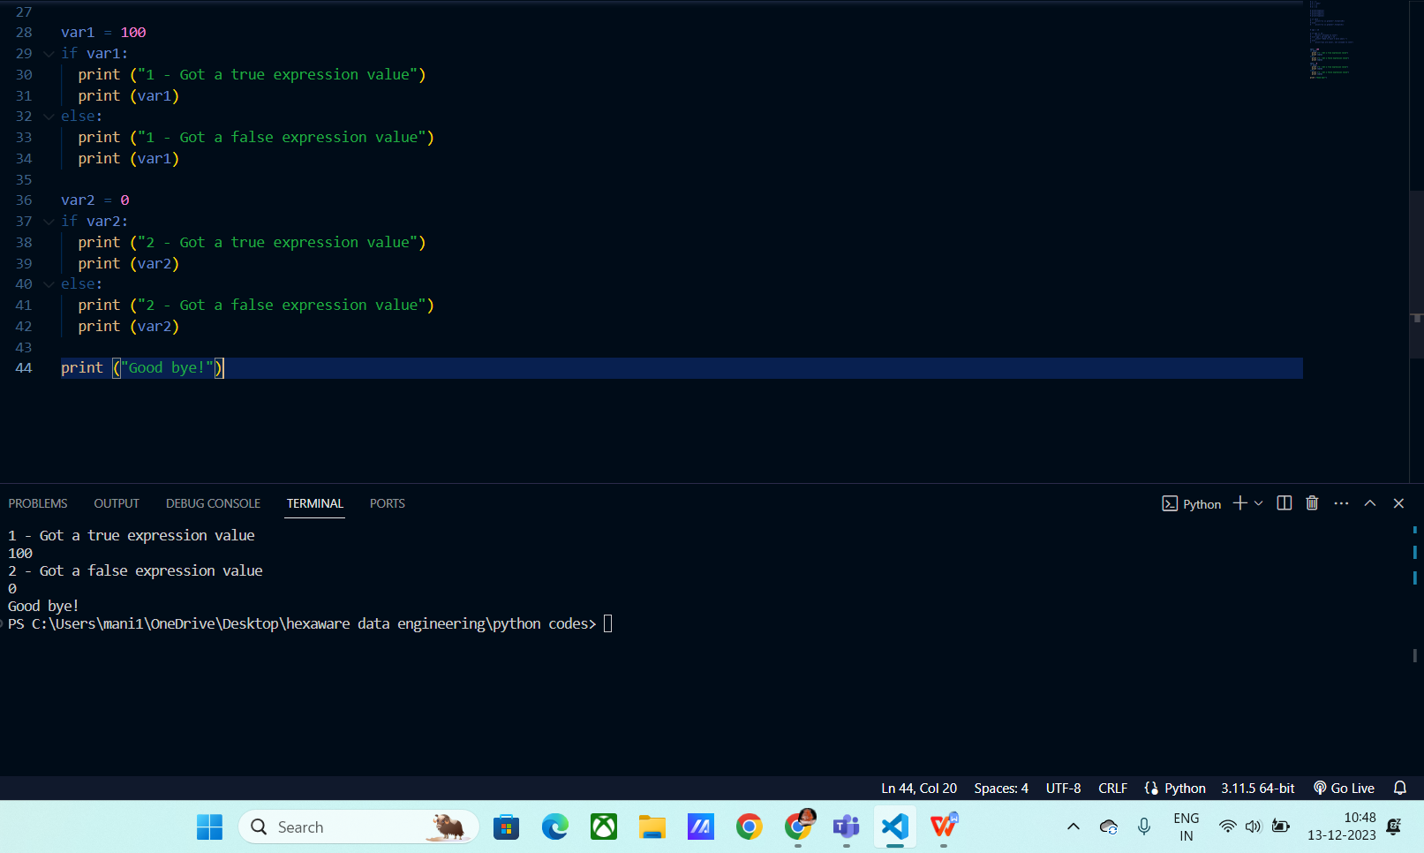

**If elif else statement :**

If condition :

Statement

Elif condition :

Statement

Else :

Statement

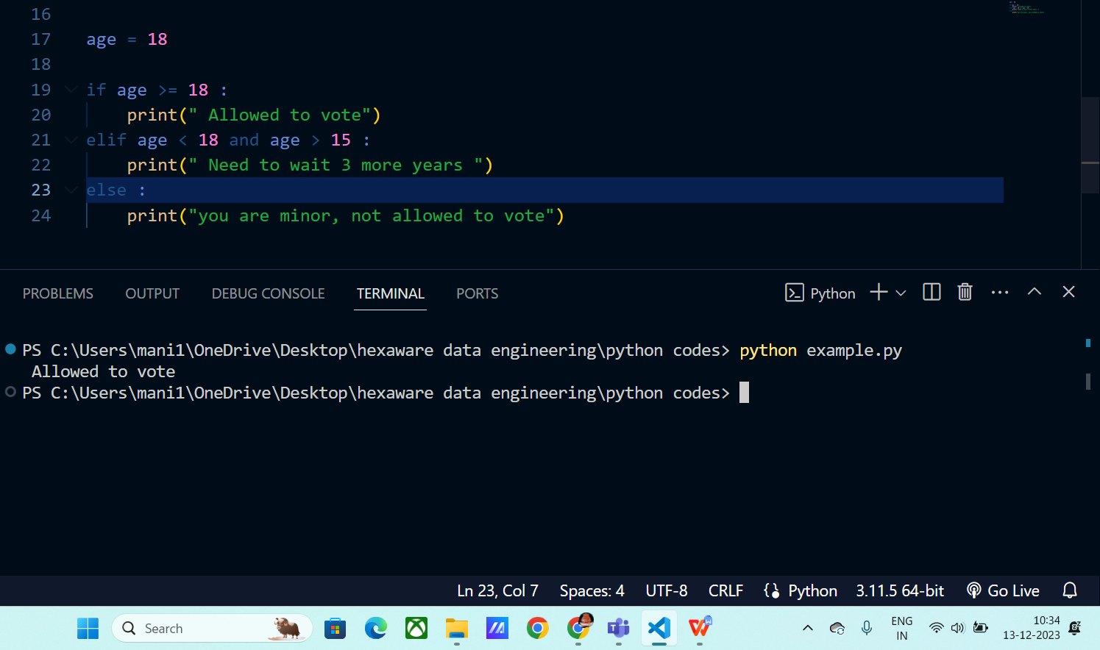

**Loops**

**While statement :**

While (condition ) :

Executes statements

# Executes the code until the condition becomes false.

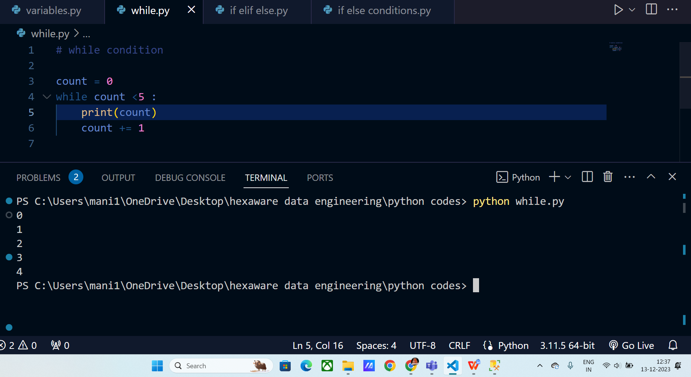

**For loop statement :**

For iterable in sequence :

Statements

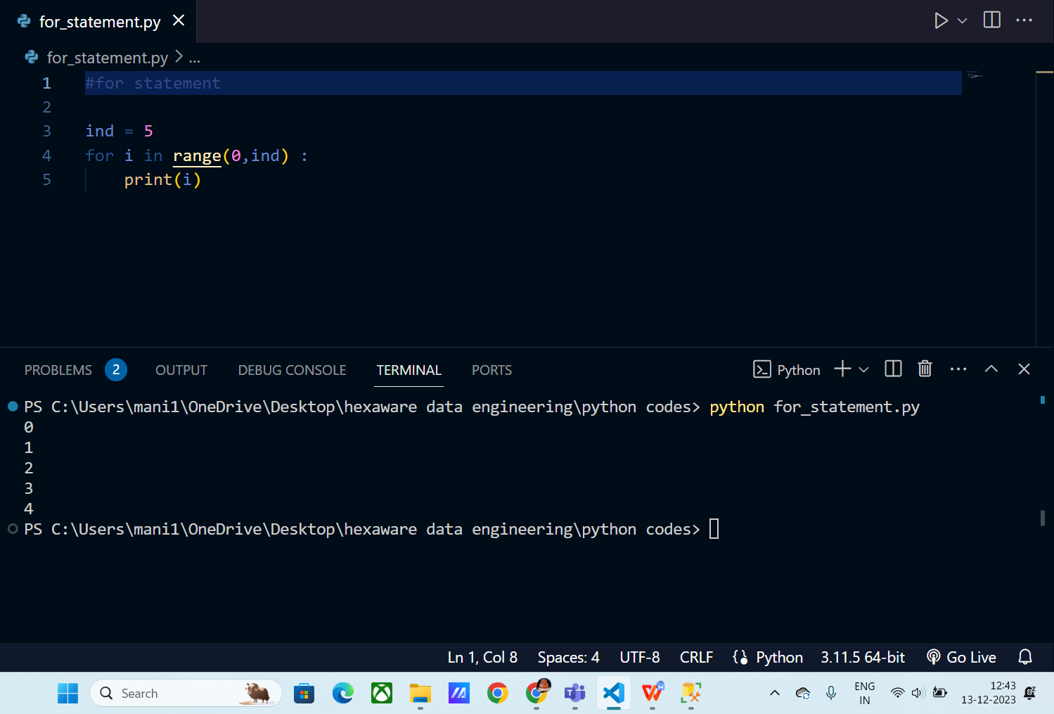

**Range :**

Syntax:

Range (start, stop, step )

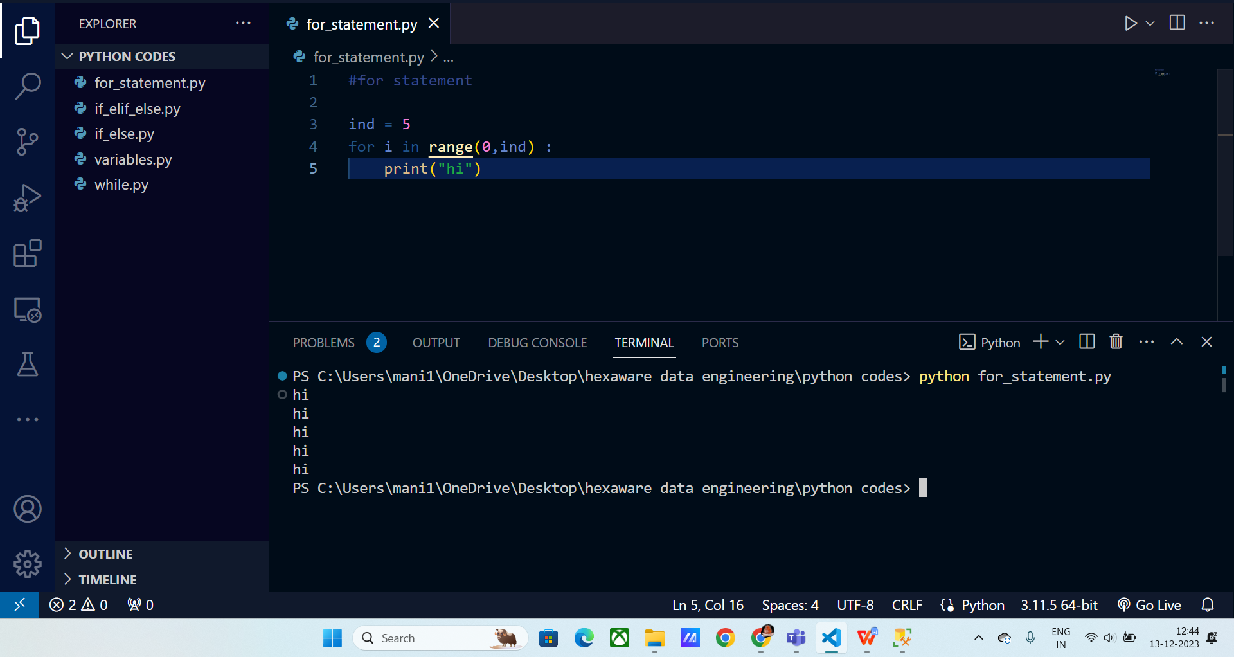

**Counting no of letter in a word :**

We will use count to store the count when each letter is visited and then at last we will return the count.

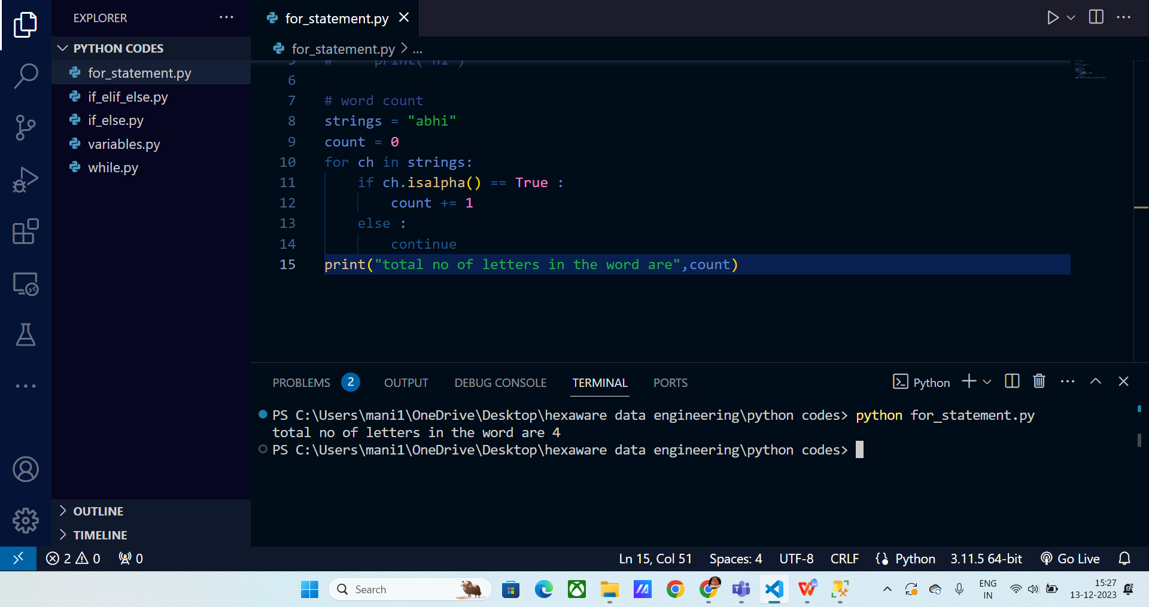

Find factorial of a number

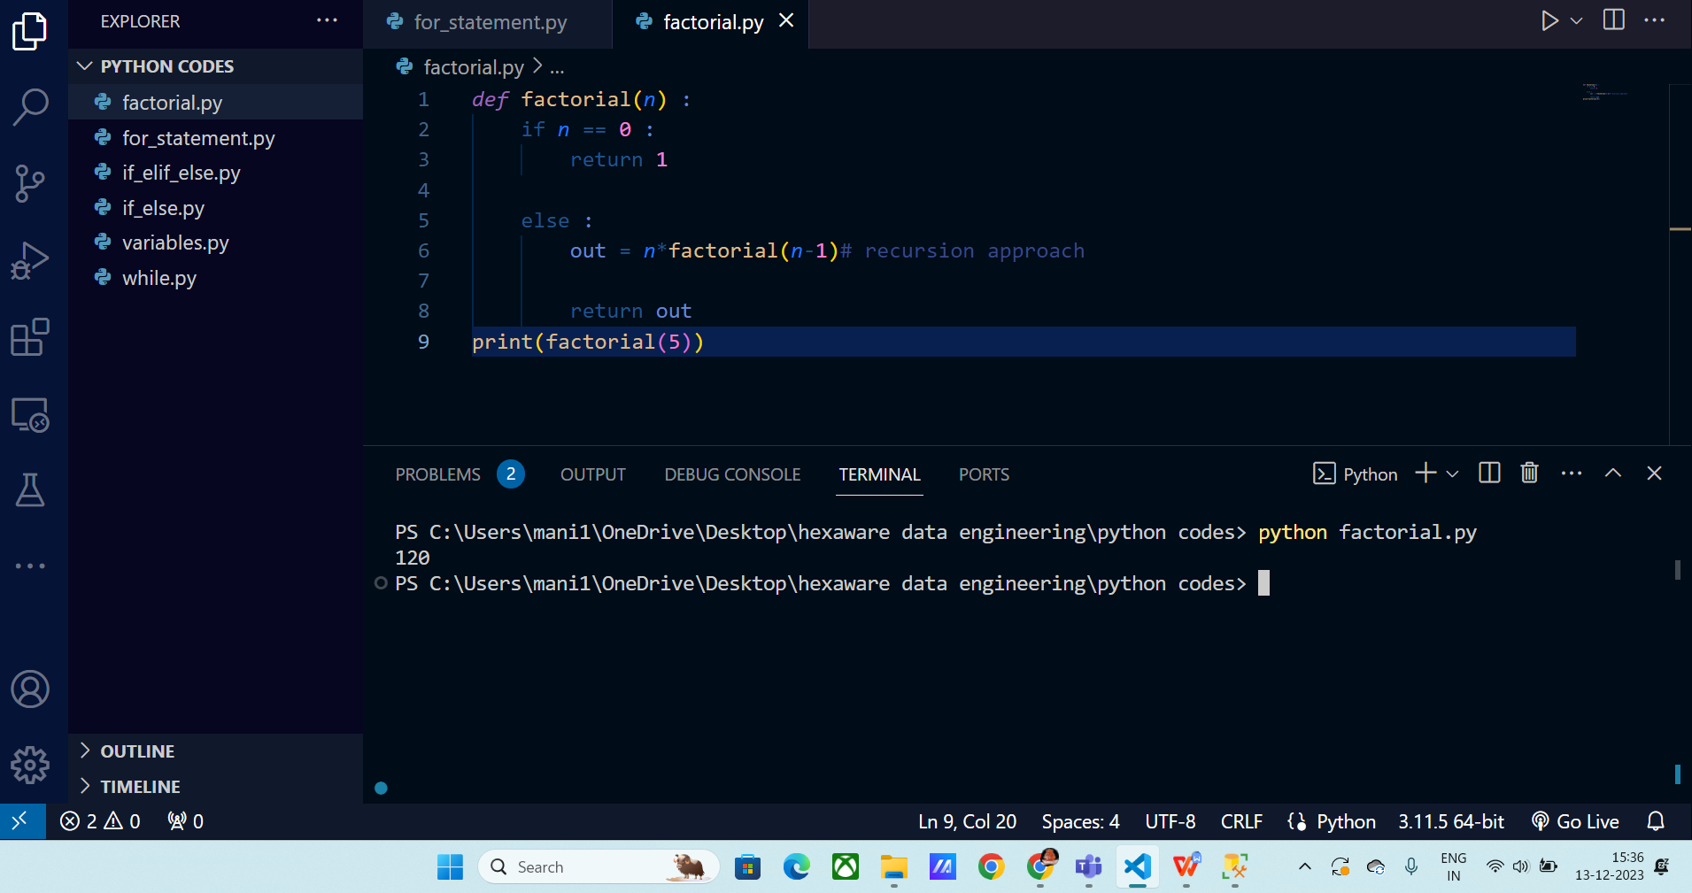

**Printing numbers using nested loops**

